MEDIKARE

Designed and developed:- Mohd Kaif.

shaikhkaif3120@gmail.com

Scope:-

The scope of the project is to build a backend and frontend web application for E-com store of a medicine retailer using spring boot and angular respectively by following REST architecture using MySQL as database and Hibernate as ORM tool. Apart from that it uses spring security robust solution along with JWT authentication token to authenticate and authorize users.

Source code:-

Backend (spring boot) : - <https://github.com/kaif3120/medikare-backend>

Frontend (Angular) :- <https://github.com/kaif3120/medikare-frontend>

Steps to install:-

Step 1:- download and install the java spring boot project from backend repository

step 2:- edit the application.properties in the backend with the database you are using.

step 3:- uncomment all the commented code in the MedikareApplication.java (root file with @SpringBootApplication annotation) while running for the first time.

step 4:- after the first time comment the code again.

step 5:- install the medikare frontend project made with angular <https://github.com/kaif3120/medikare-frontend>.

step 6:- edit the baseUrl in helper.ts in services folder to the url you are running your spring boot application on.

step 7:- login as admin with credentials admin as username and password or create a new user with registration form.

SPRINT PLANNING

* No. of sprints:- 2
* Duration : - 1 week
* Product backlog:-
* T101- Create spring boot Application and model for User, Roles, Product, Cart, Purchase and Category.
* T102- Make database and map the model to it using Hibernate
* T103- Make JWT authentication System with Spring security
* T104- Make REST APIs for the products, users, category, cart and purchases.
* T105- Create frontend using angular and material UI
* T106- Make pages for login, registration, shop, product, cart and admin dashboard
* T107- Implement crud operations for Category and products in admin dashboard
* T108- Add Cart and product validation and login and registration validation too.

Sprint Breakdown:-

Sprint 1:-

* Sprint backlog: -
* T101 :- story points - 8

description : - Create spring boot Application and model for

Users, Roles, Product, Cart, Purchase and Category.

Assigned to :- Mohd Kaif

Acceptance criteria :- above mentioned work should be

implemented properly

* T102 :- story points - 8

description : - Make database and map the model to it using

Hibernate

Assigned to :- Mohd Kaif

Acceptance criteria :- above mentioned work should be

implemented properly.

* T103 :- story points - 8

description : - Make JWT authentication System with Spring

security

Assigned to :- Mohd Kaif

Acceptance criteria :- above mentioned work should be

implemented properly.

* T104 :- story points - 8

description : - Make REST APIs for the products, users, category,

cart and purchases.

Assigned to :- Mohd Kaif

Acceptance criteria :- above mentioned work should be

implemented properly.

Sprint 2:-

* Sprint backlog: -
* T105 :- story points - 8

description : - Create frontend using angular and material UI

Assigned to :- Mohd Kaif

Acceptance criteria :- above mentioned work should be

implemented properly

* T106 :- story points - 8

description : - Make pages for login, registration, shop, product,

cart and admin dashboard

Assigned to :- Mohd Kaif

Acceptance criteria :- above mentioned work should be

implemented properly.

* T107 :- story points - 8

description : - Implement crud operations for Category and

products in admin dashboard

Assigned to :- Mohd Kaif

Acceptance criteria :- above mentioned work should be

implemented properly.

* T108 :- story points - 8

description : - Add Cart and product validation and login and

registration validation too.

Assigned to :- Mohd Kaif

Acceptance criteria :- above mentioned work should be

implemented properly.

Technologies used

* Backend:- Spring boot, spring data jpa, spring security, JWT Authentication.
* Frontend:- Angular, Bootstrap, Material UI
* Database:- MySQL (Hibernate as ORM)

SCREENSHOTS:-

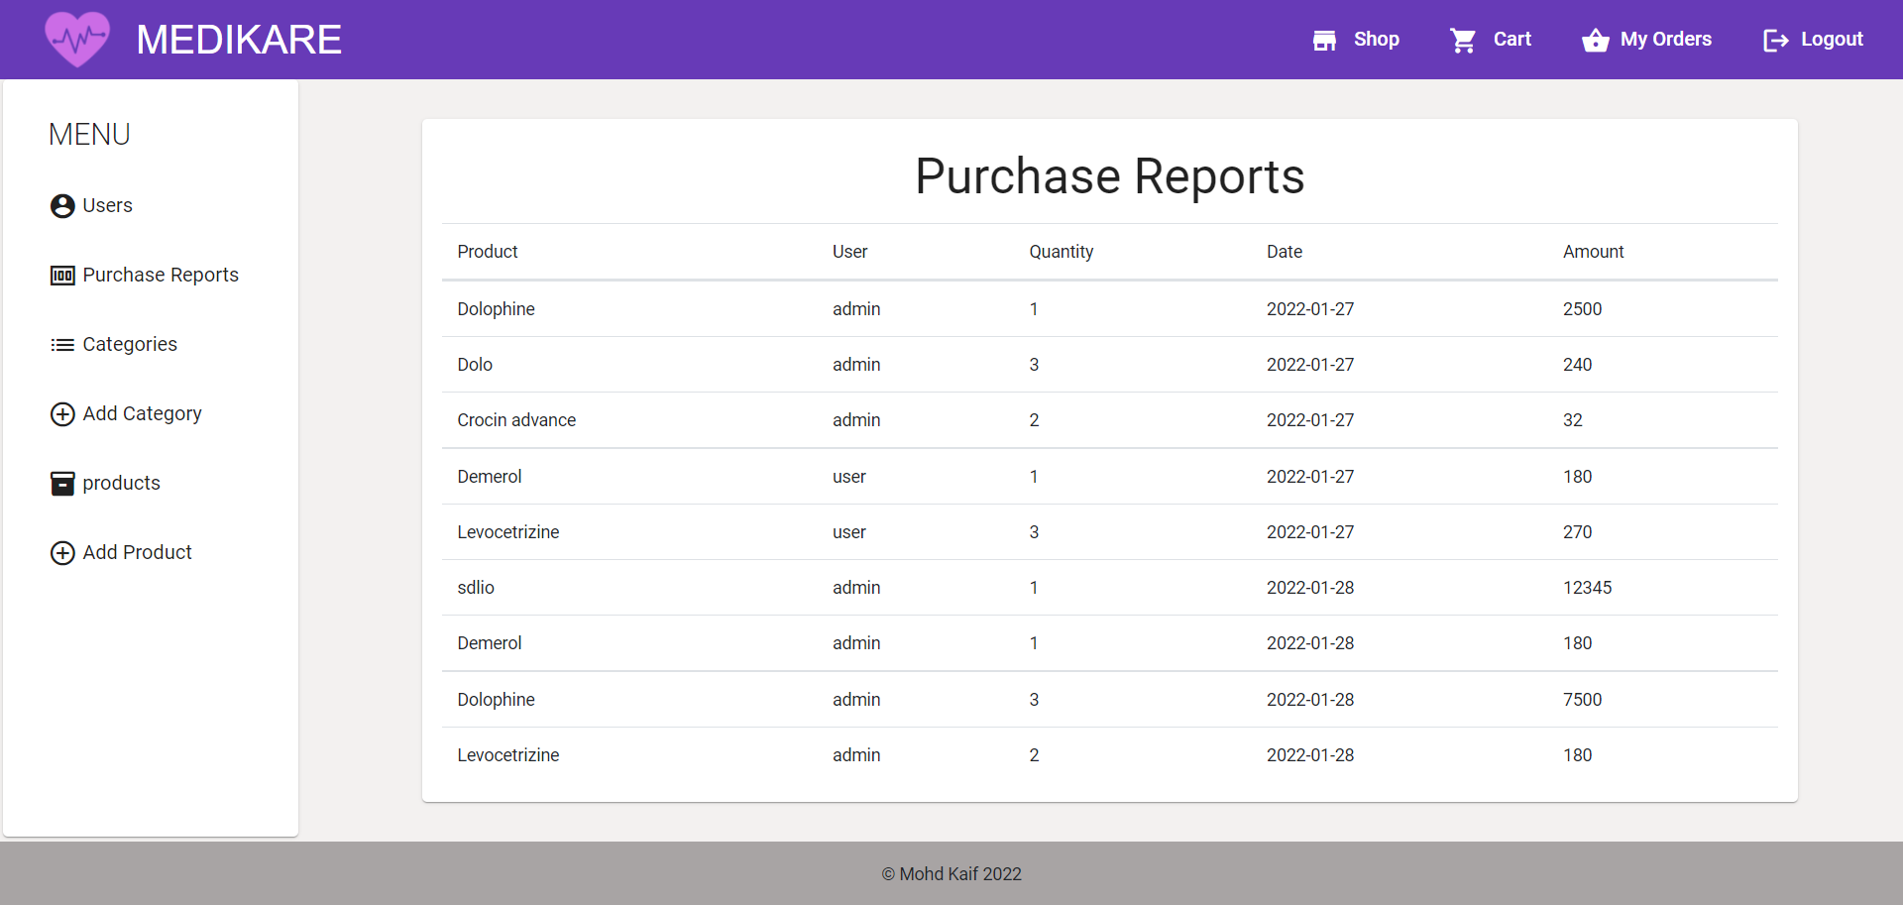

Admin dashboard- all purchase reports.

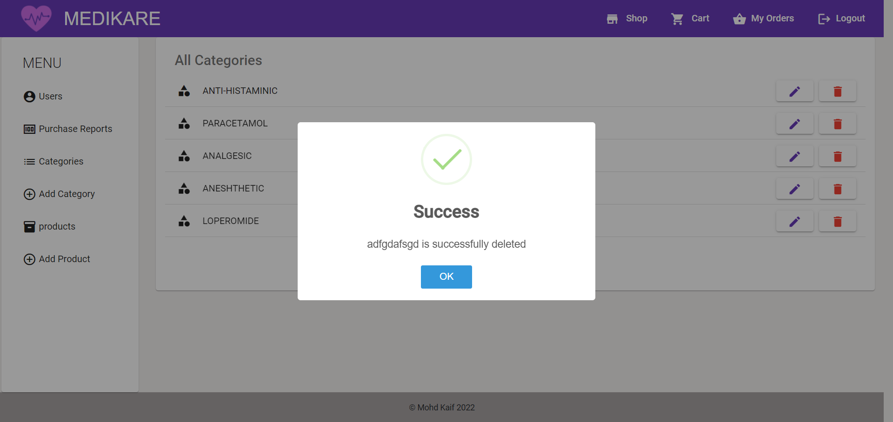

admin dashboard- category delete page

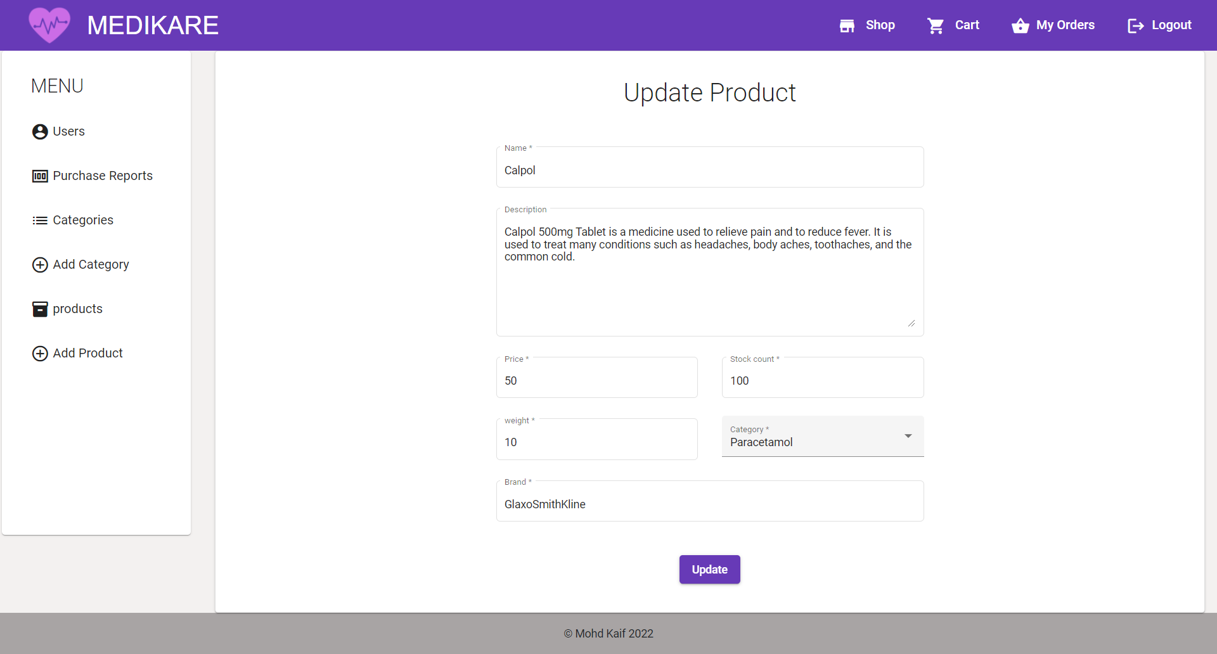

admin dashboard update product page

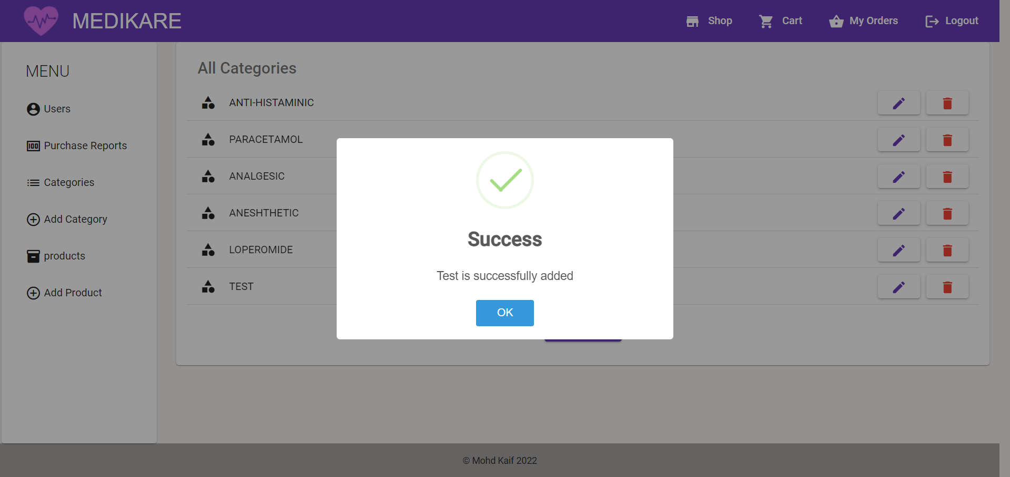admin-dashboard category add validation

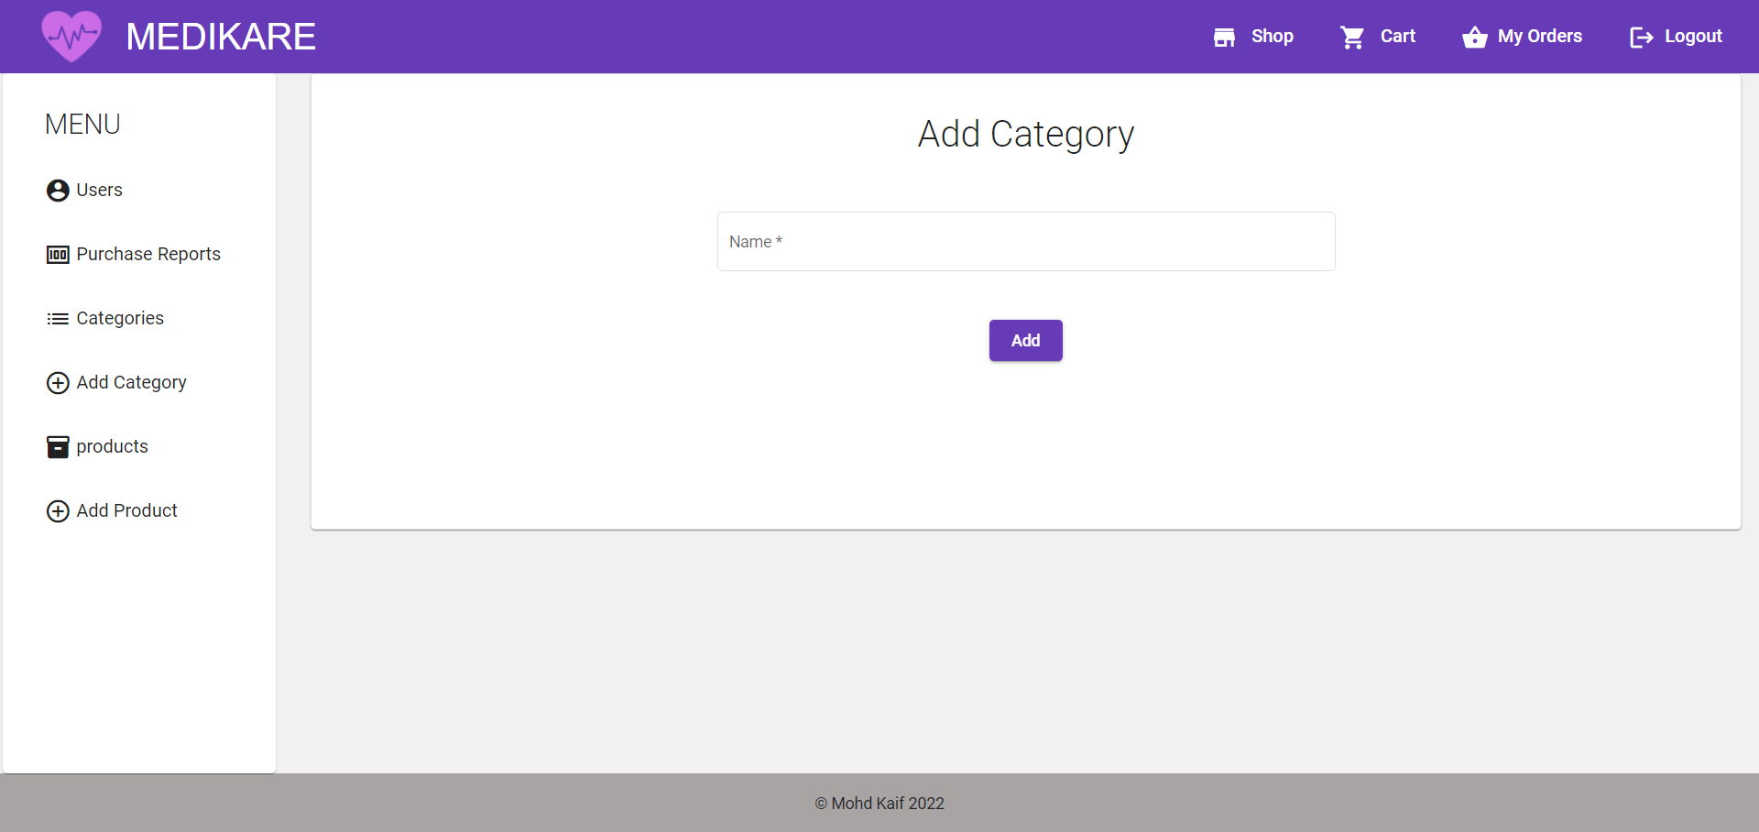

admin-dashboard add category page

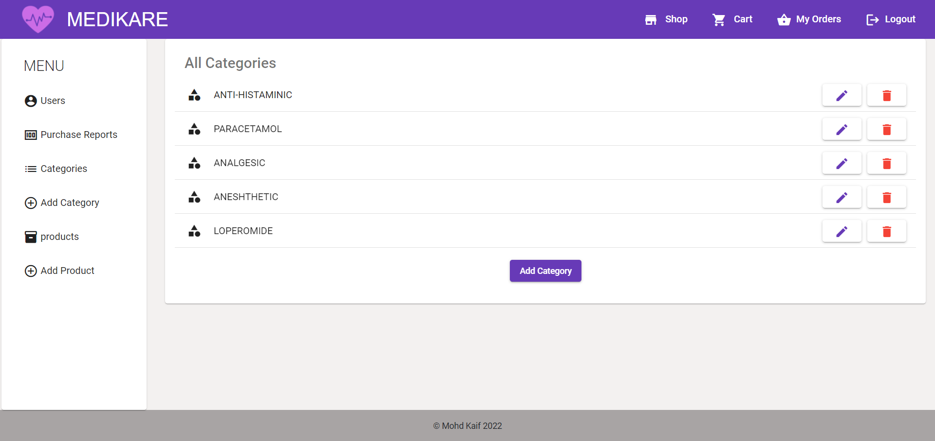admin-dashboard categories list

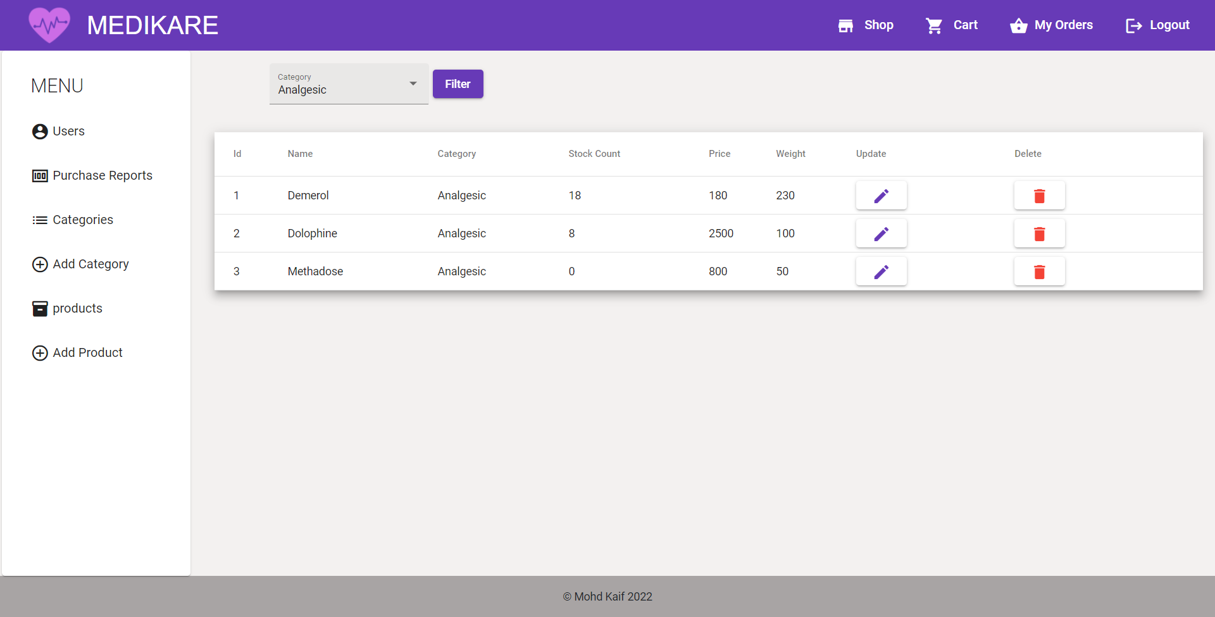admin-dashboard products filter

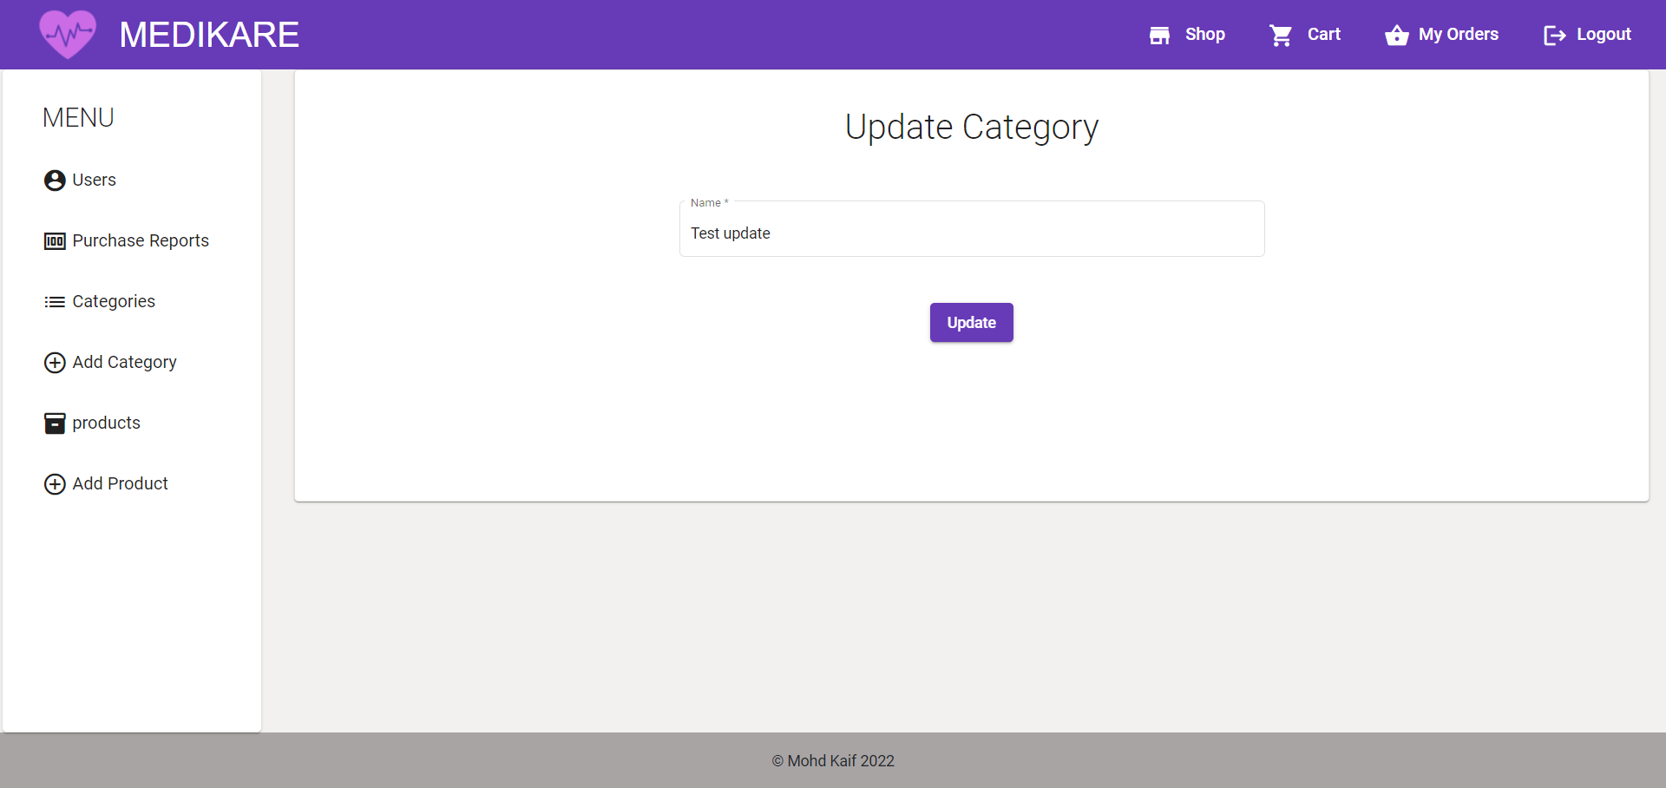admin-dashboard update category

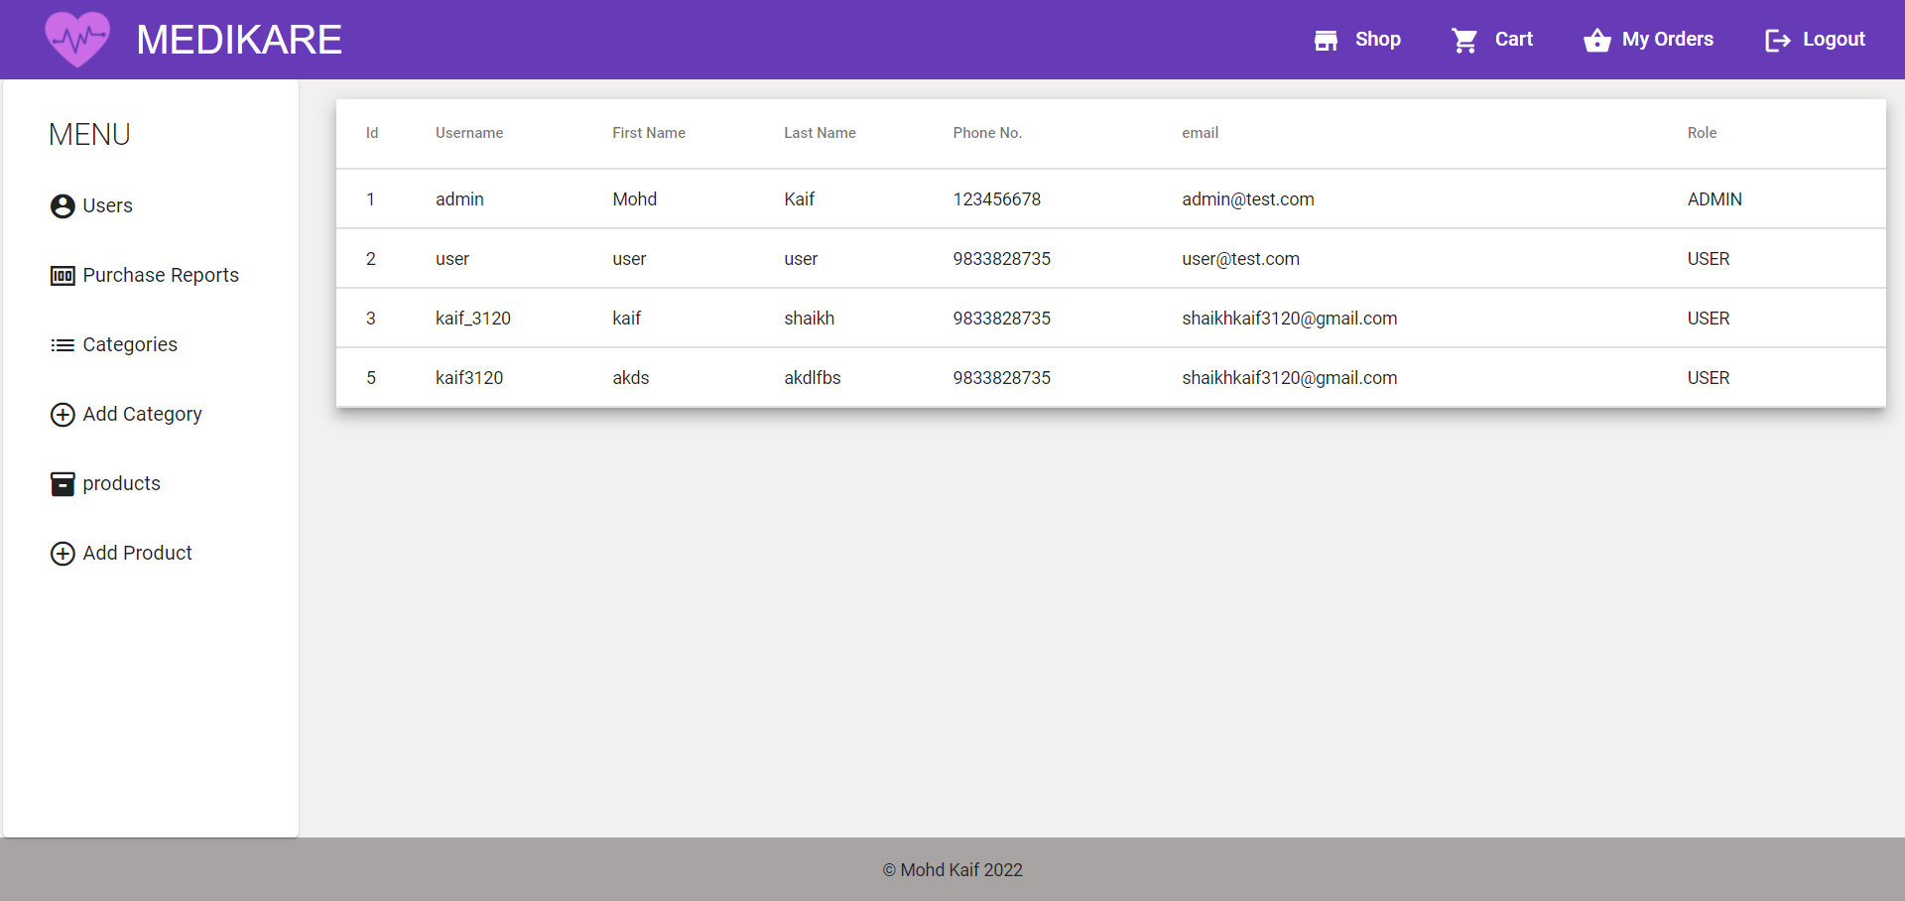admin-dashboard users list

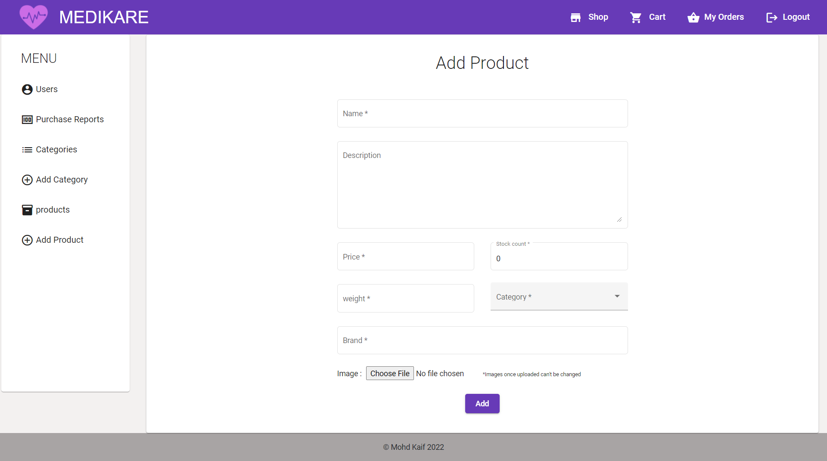admin-dashboard-products add page

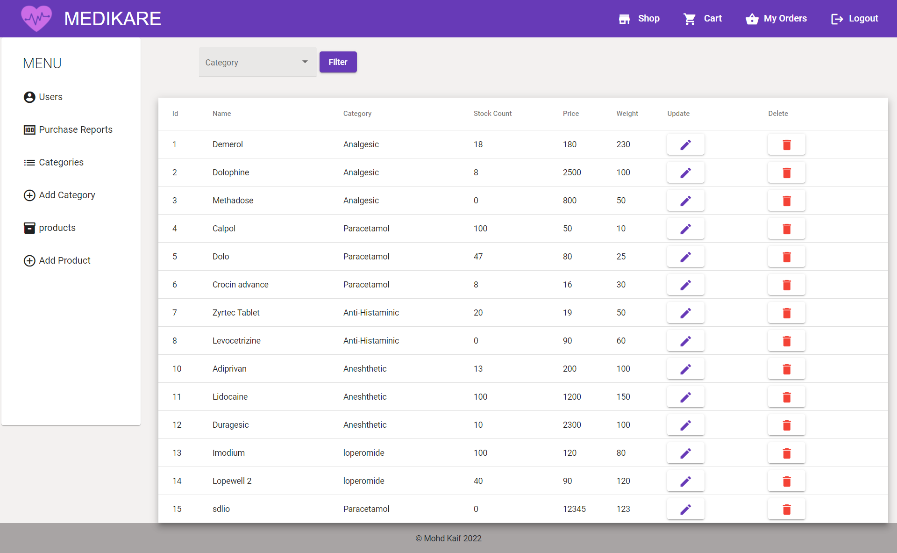admin-dashboard-products list

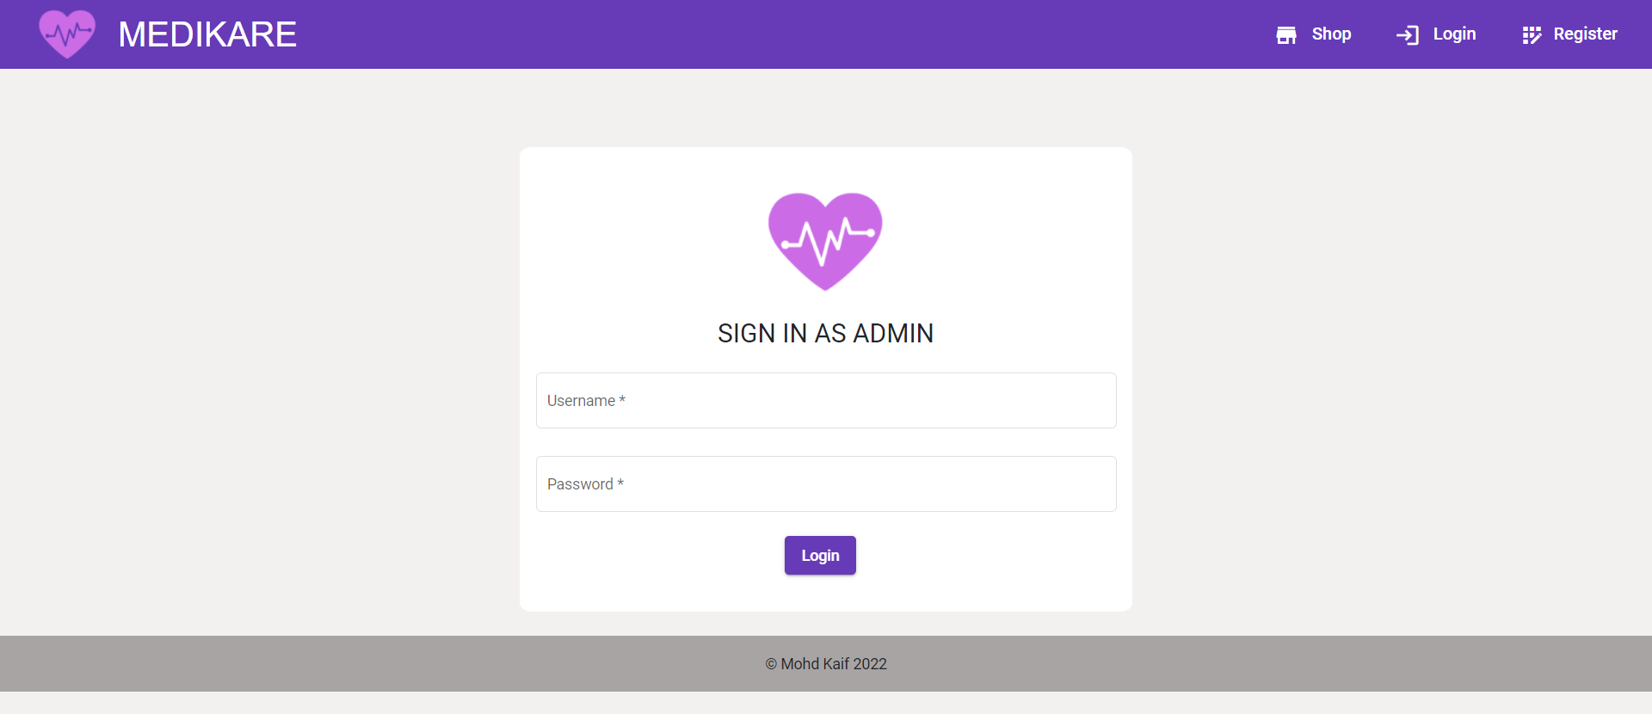admin-login

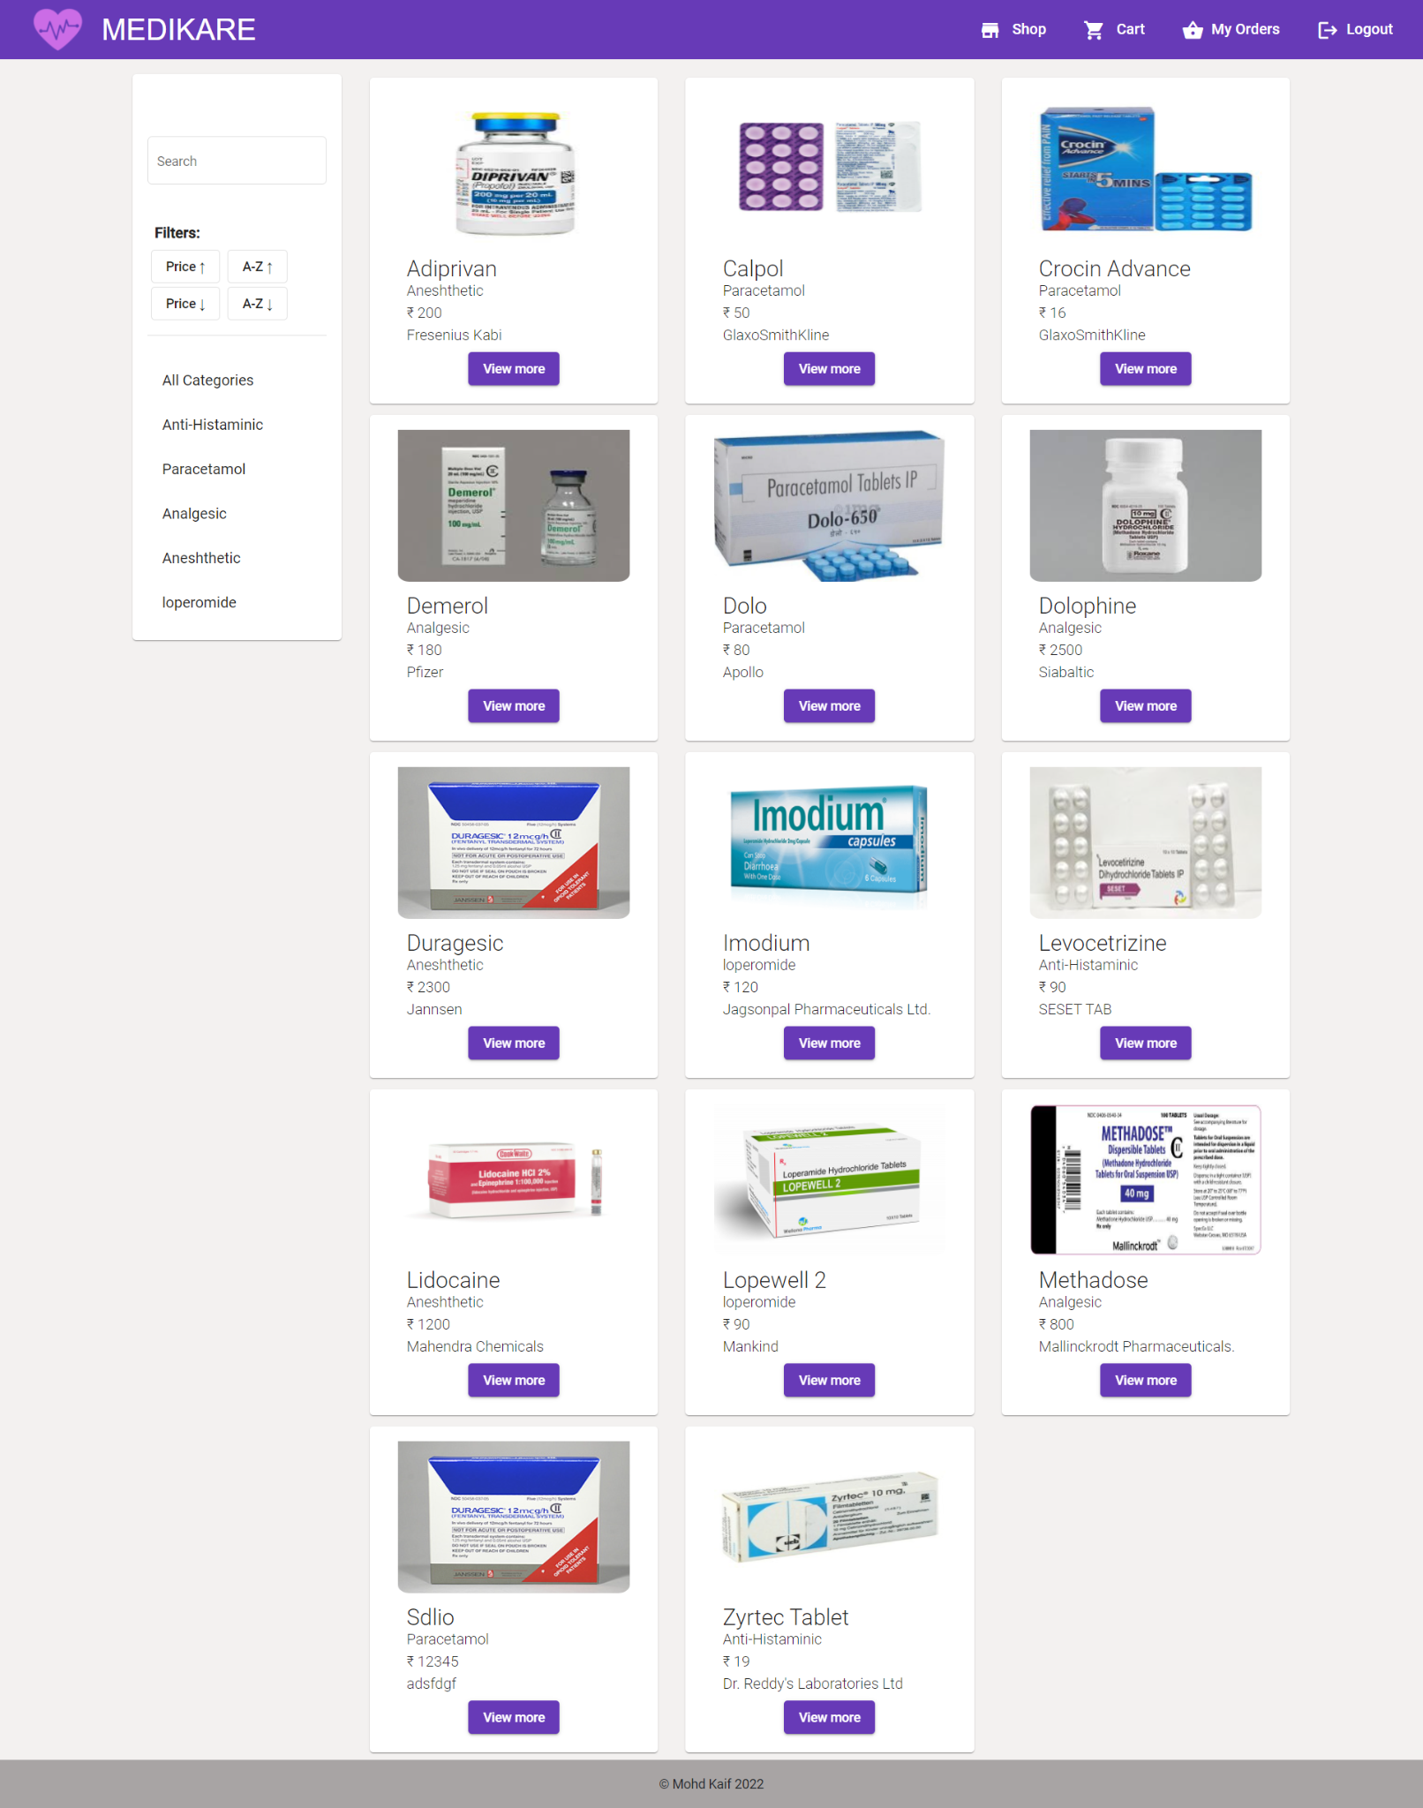ascending alphabet sort

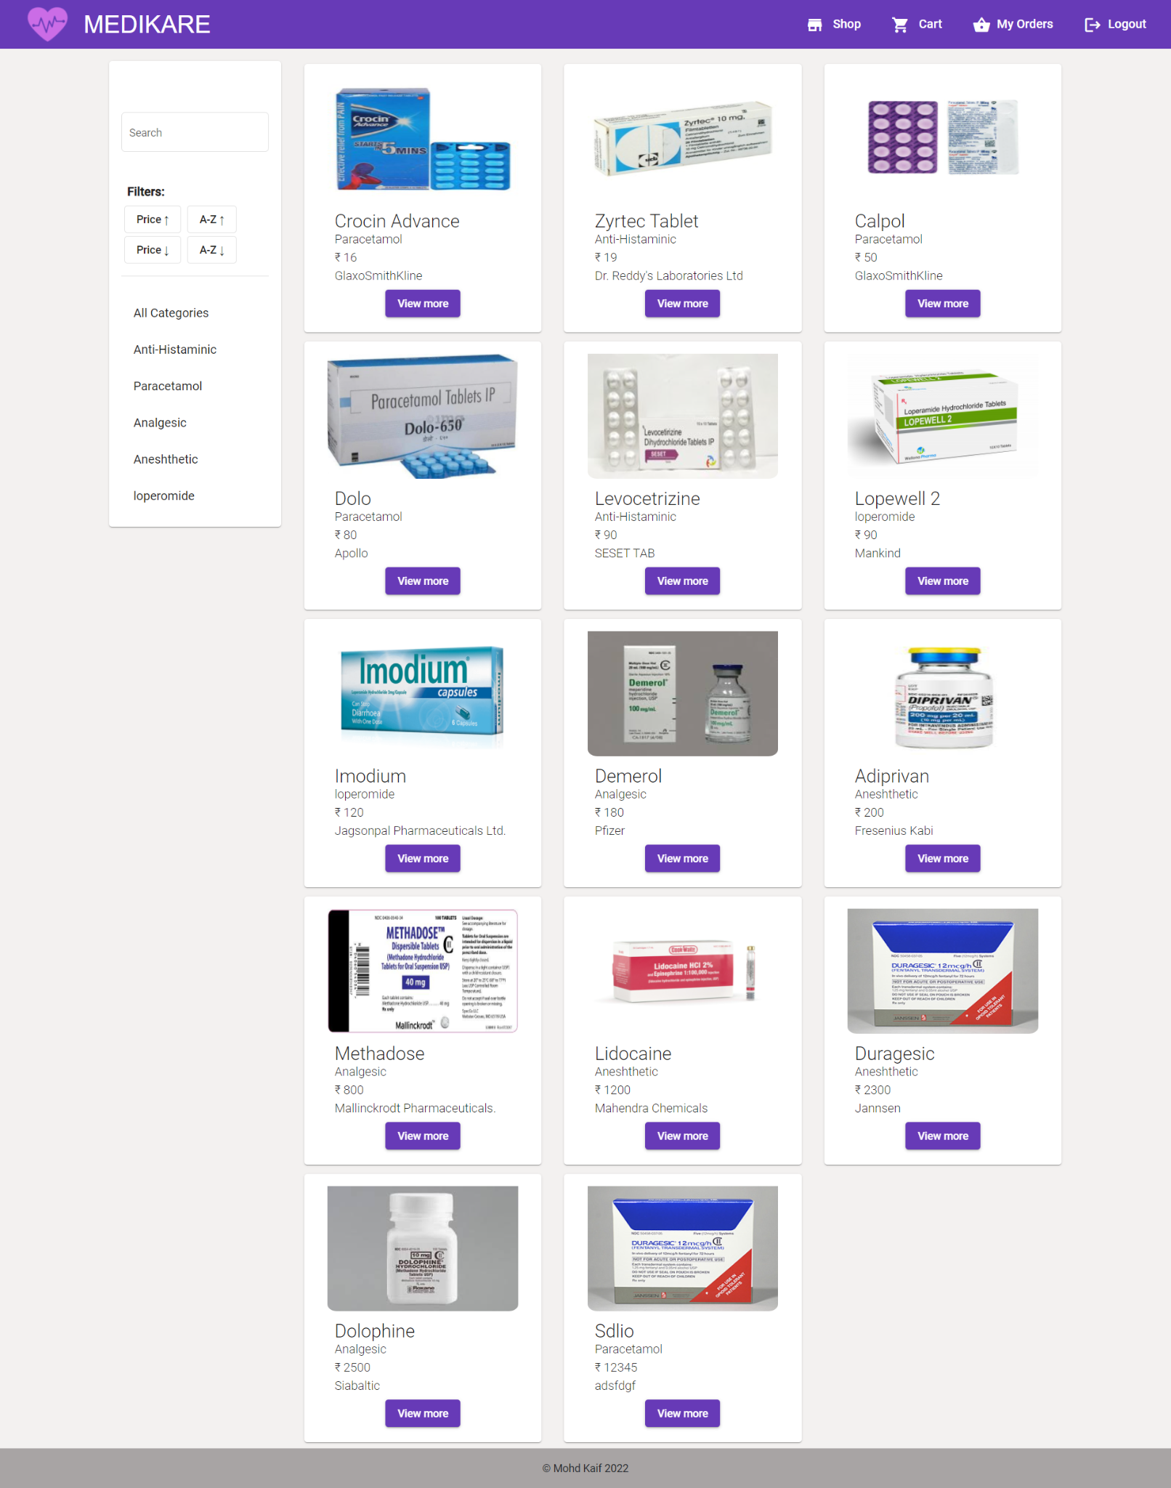ascending prize sort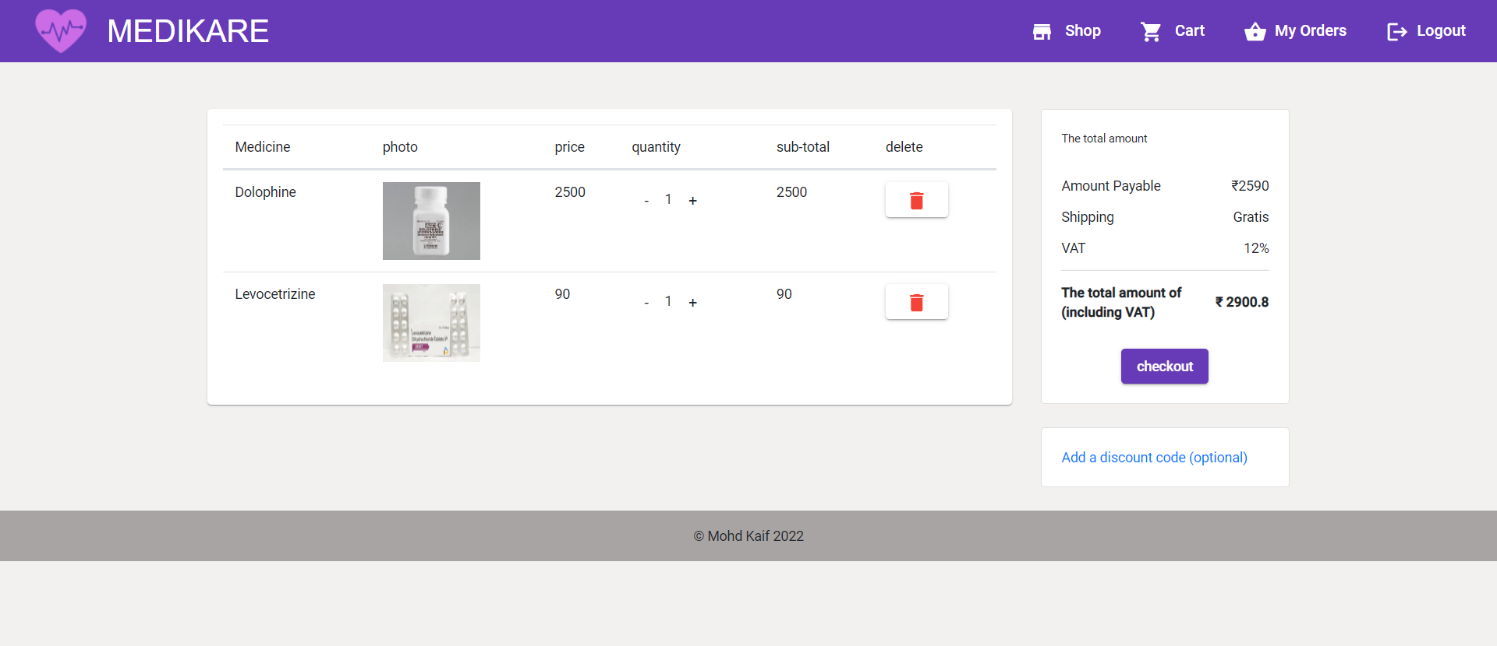cart page

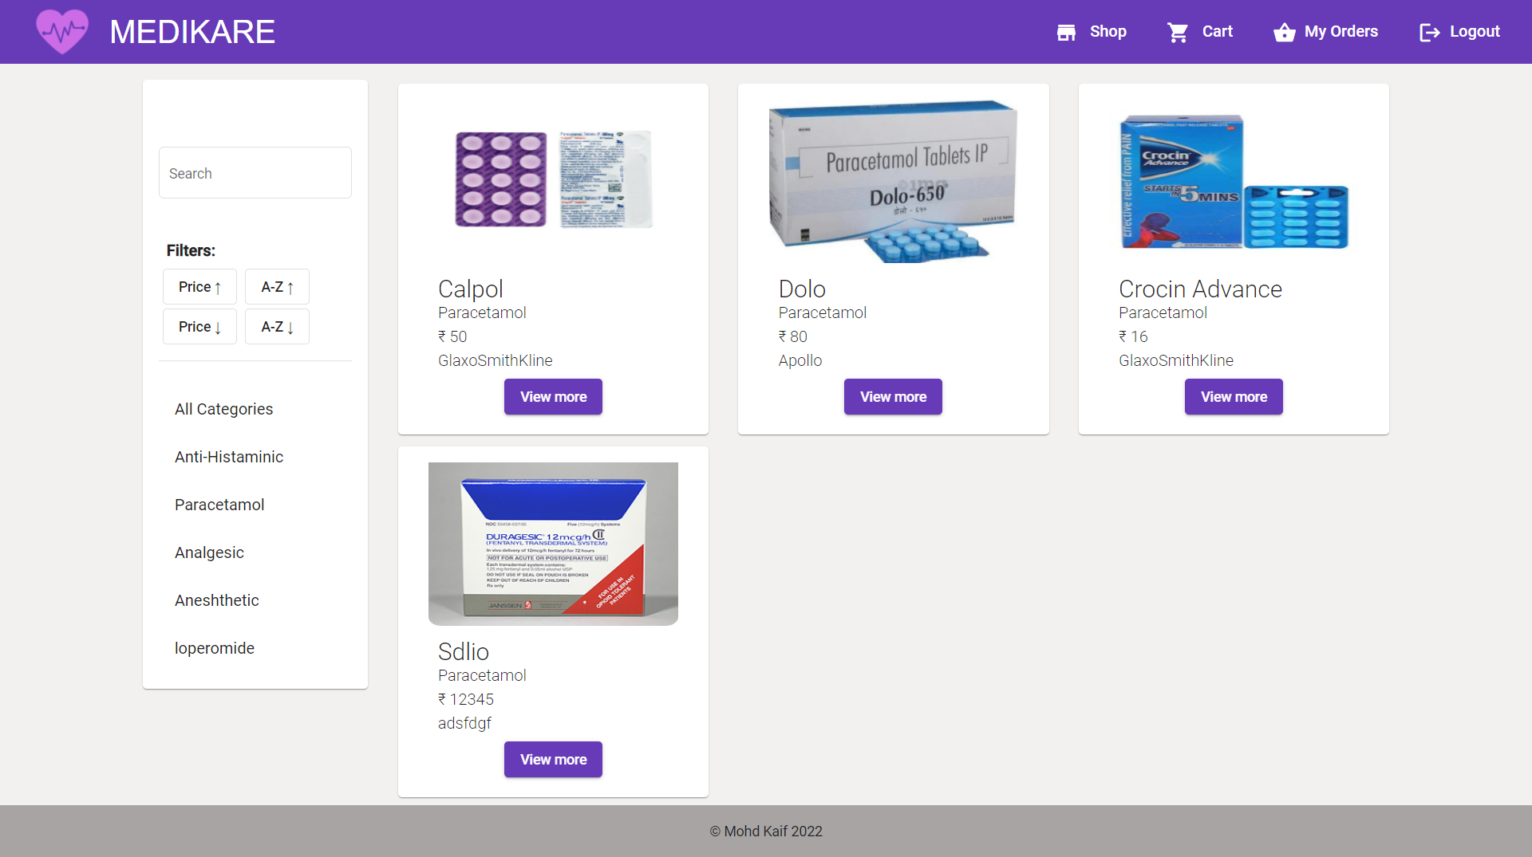category based results

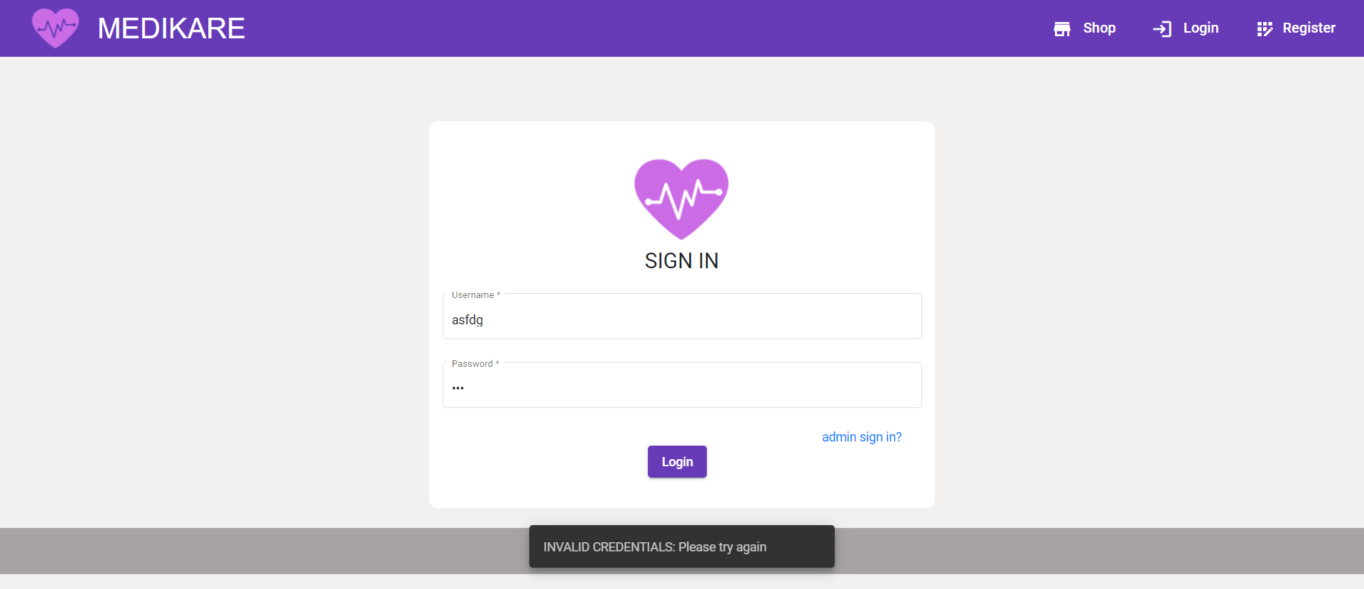credentials validation

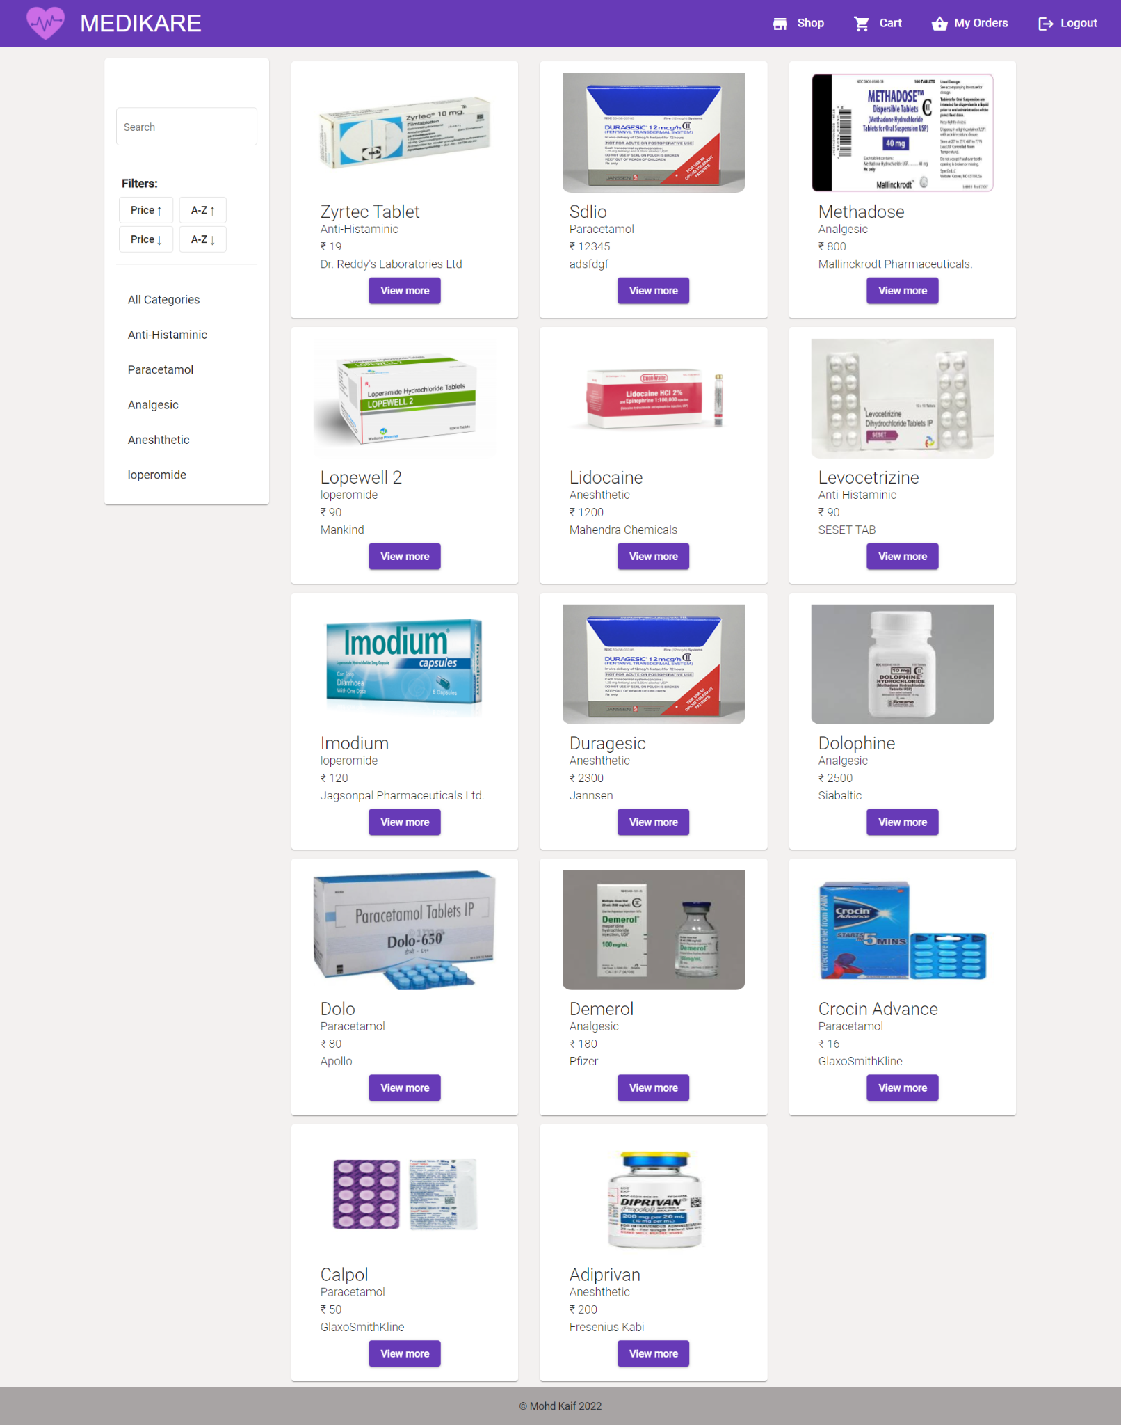descending alphabet sort

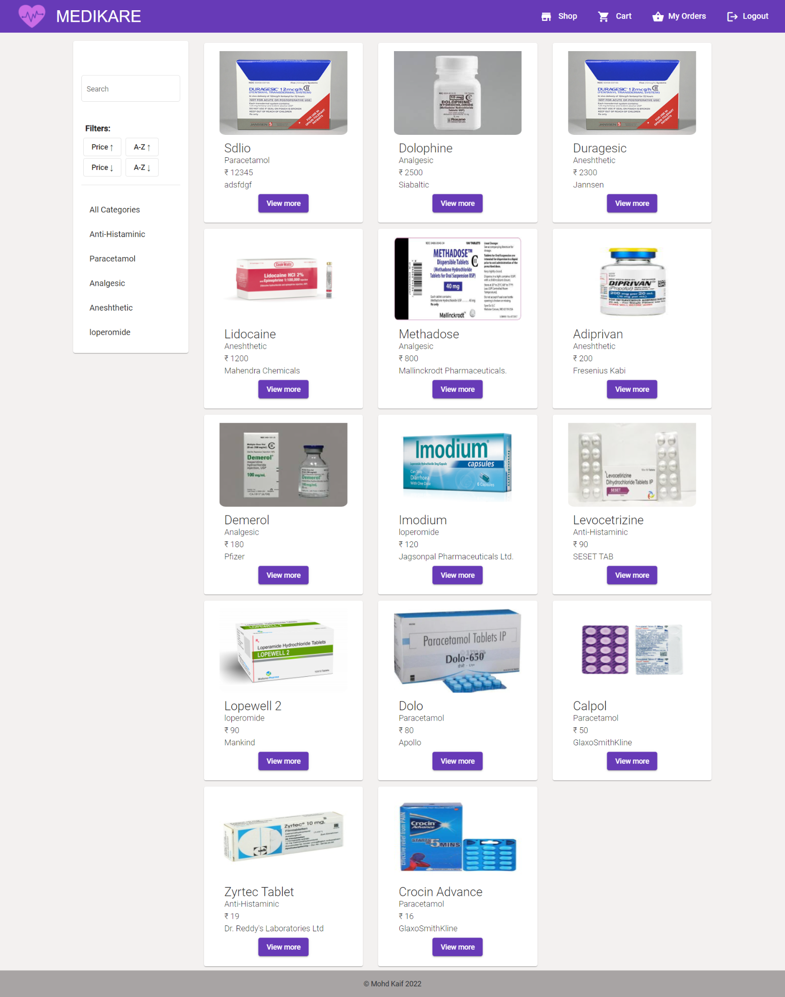descending prize sorrt

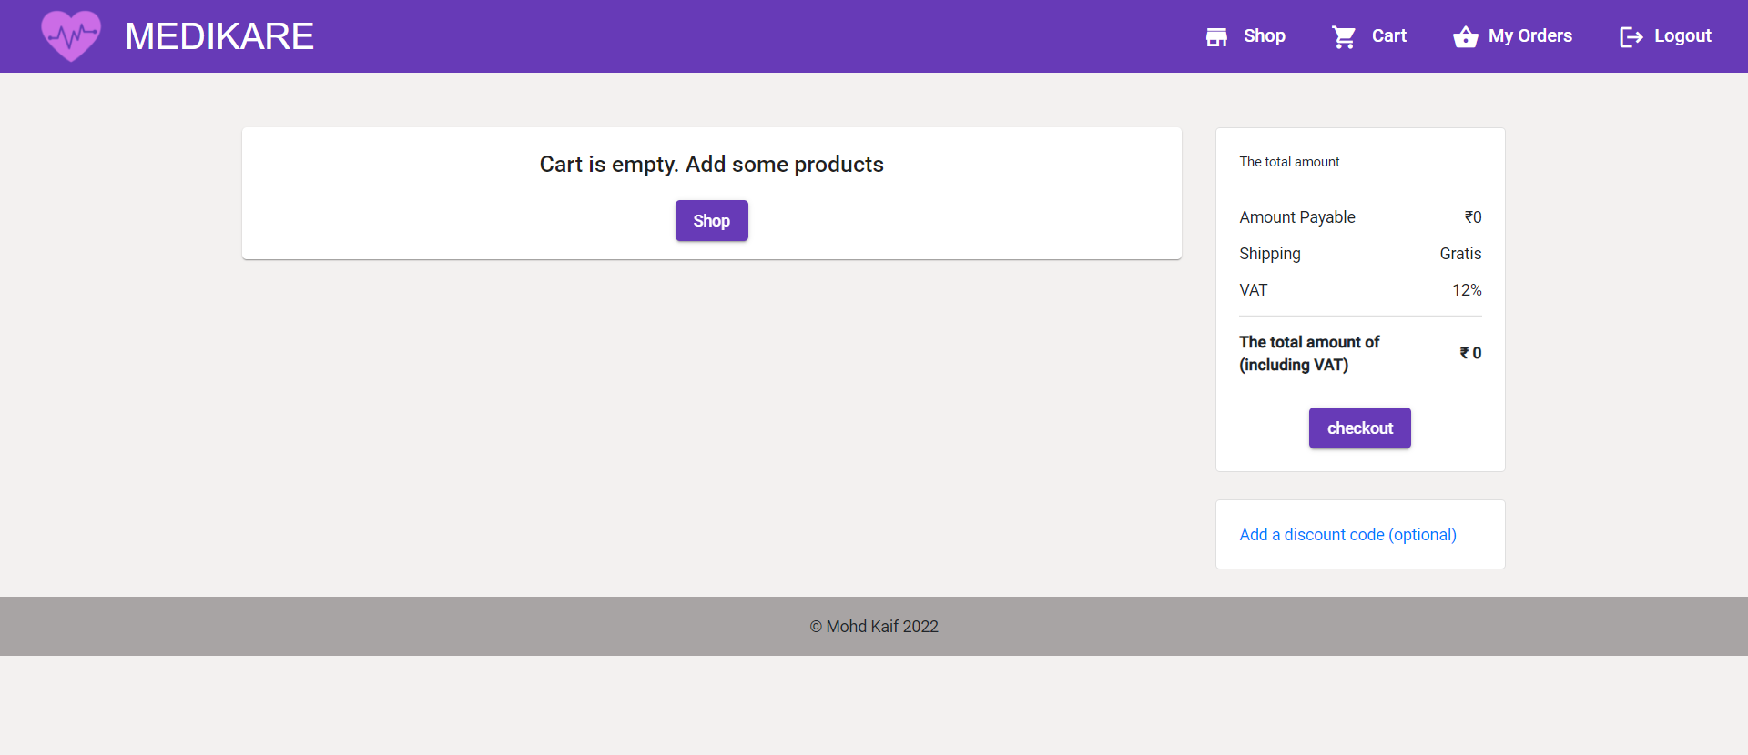empty cart page

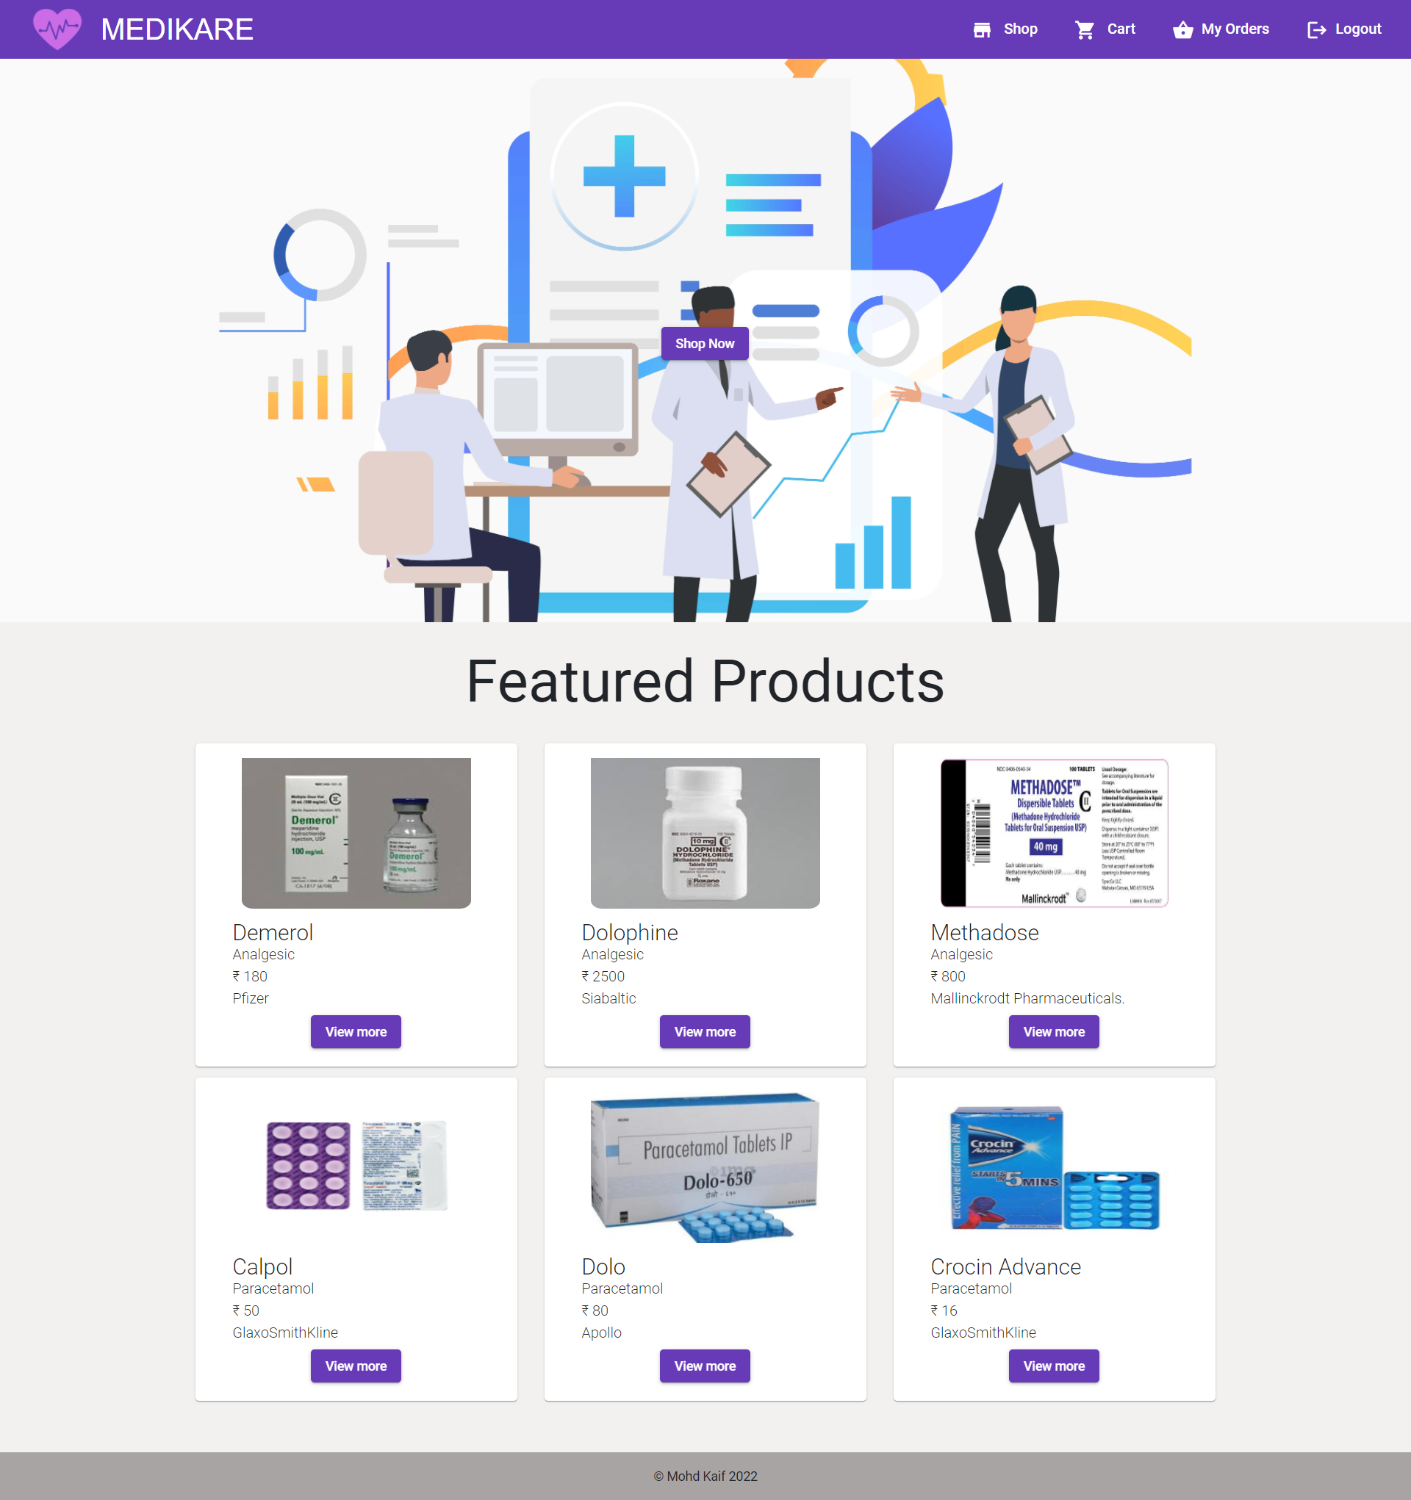home-loggedin

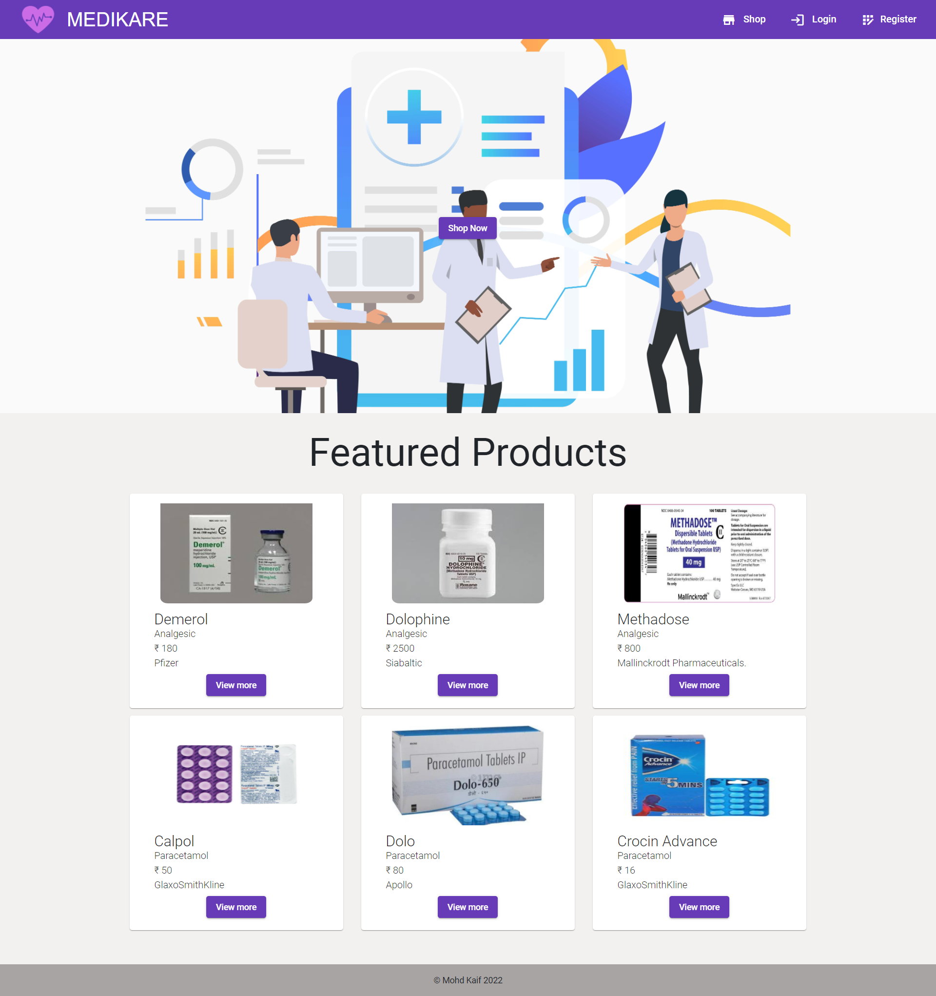home-notloggedin

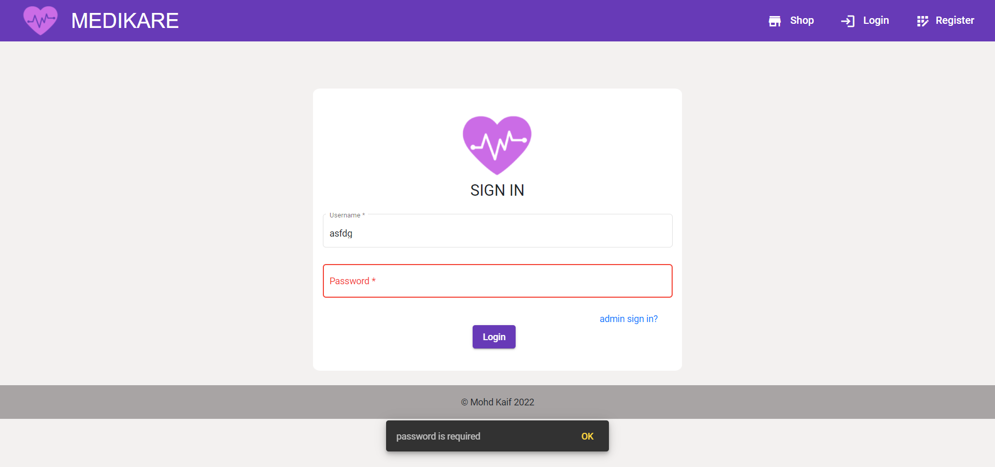login validation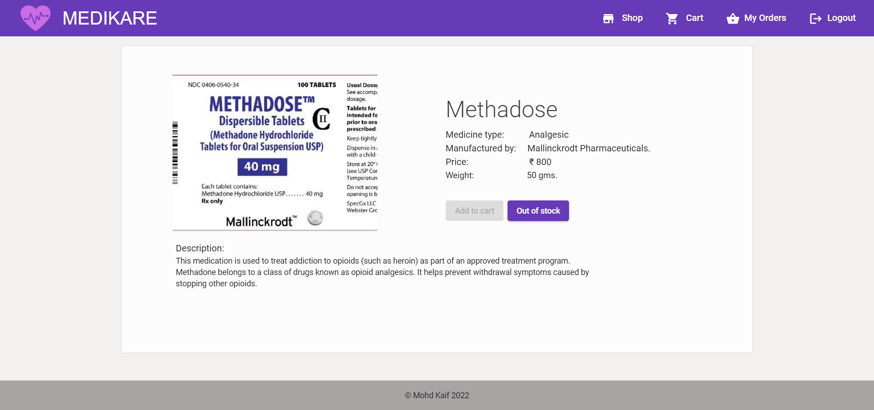out of stock product

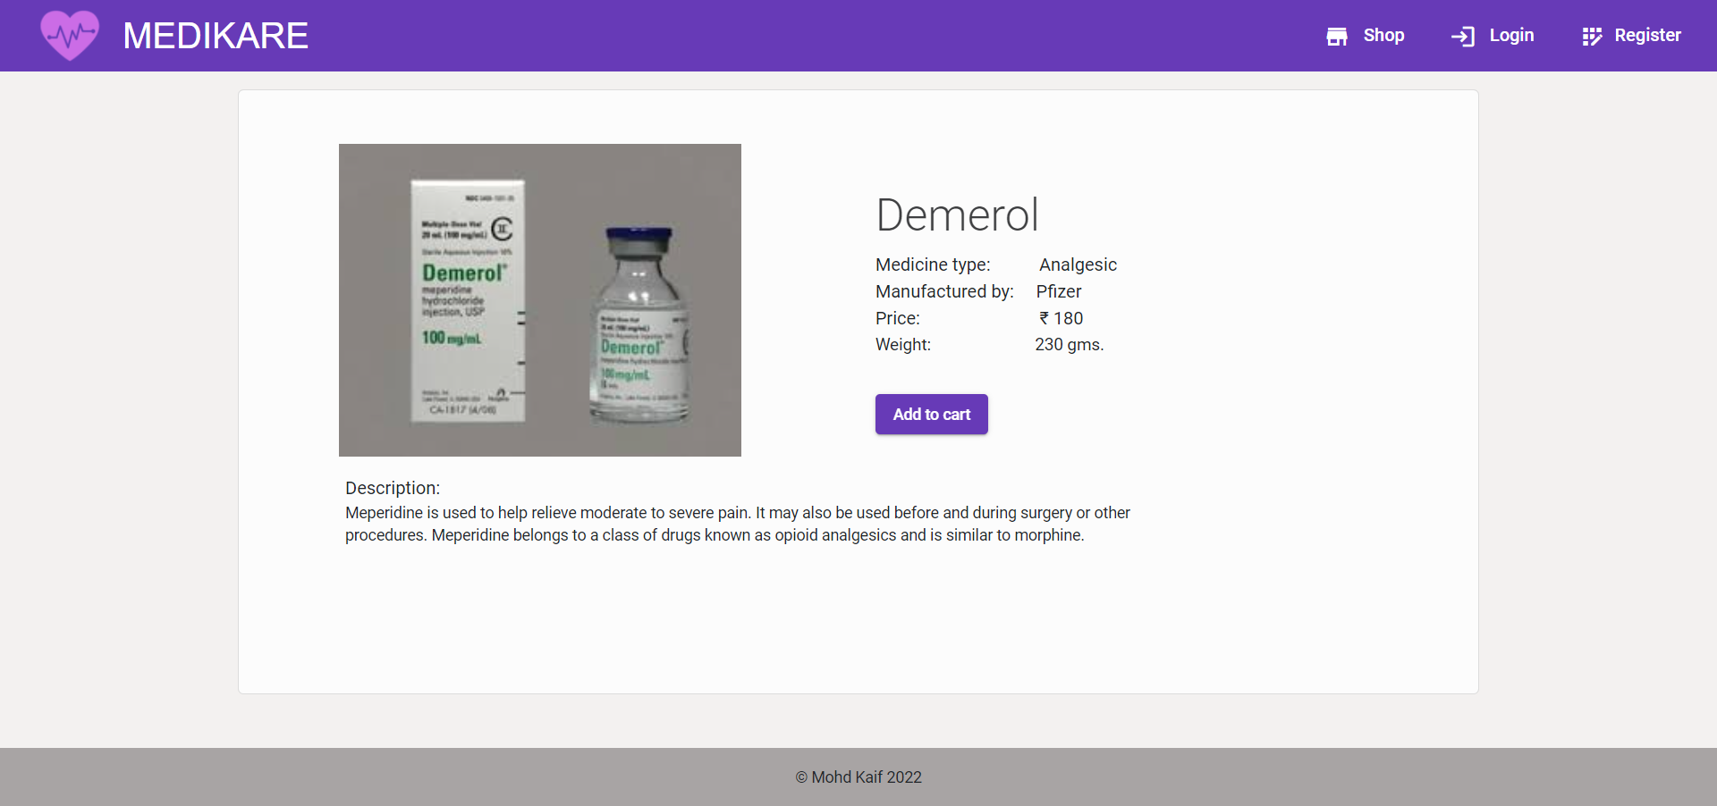product page

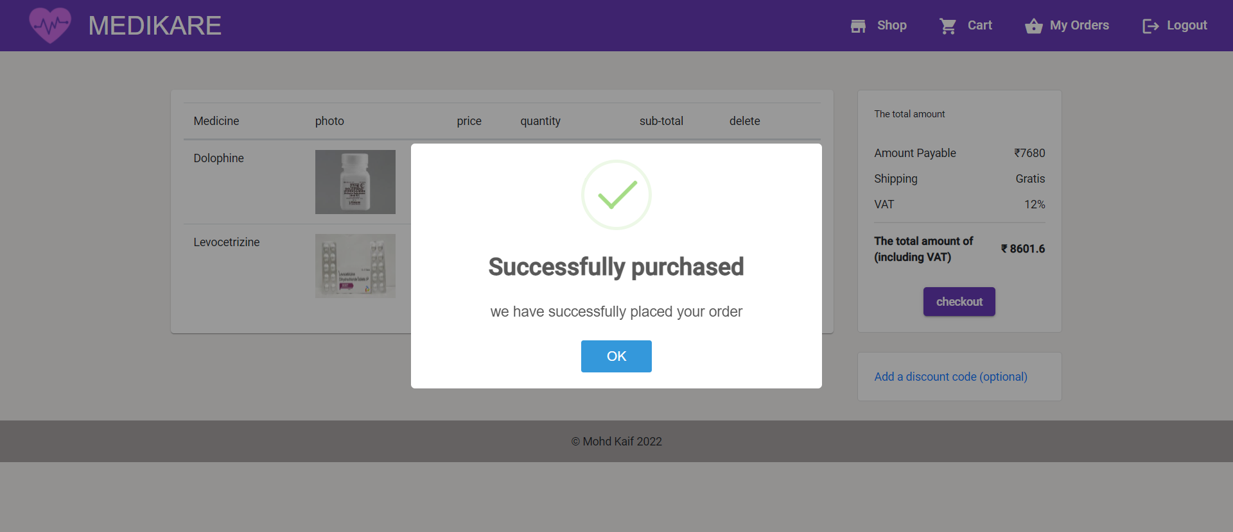purchase validation

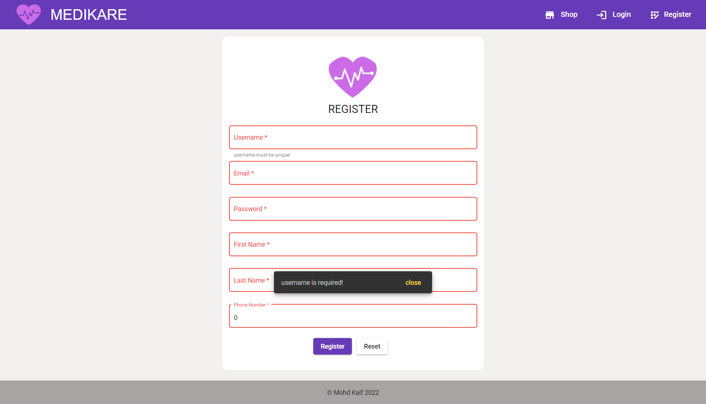register validation

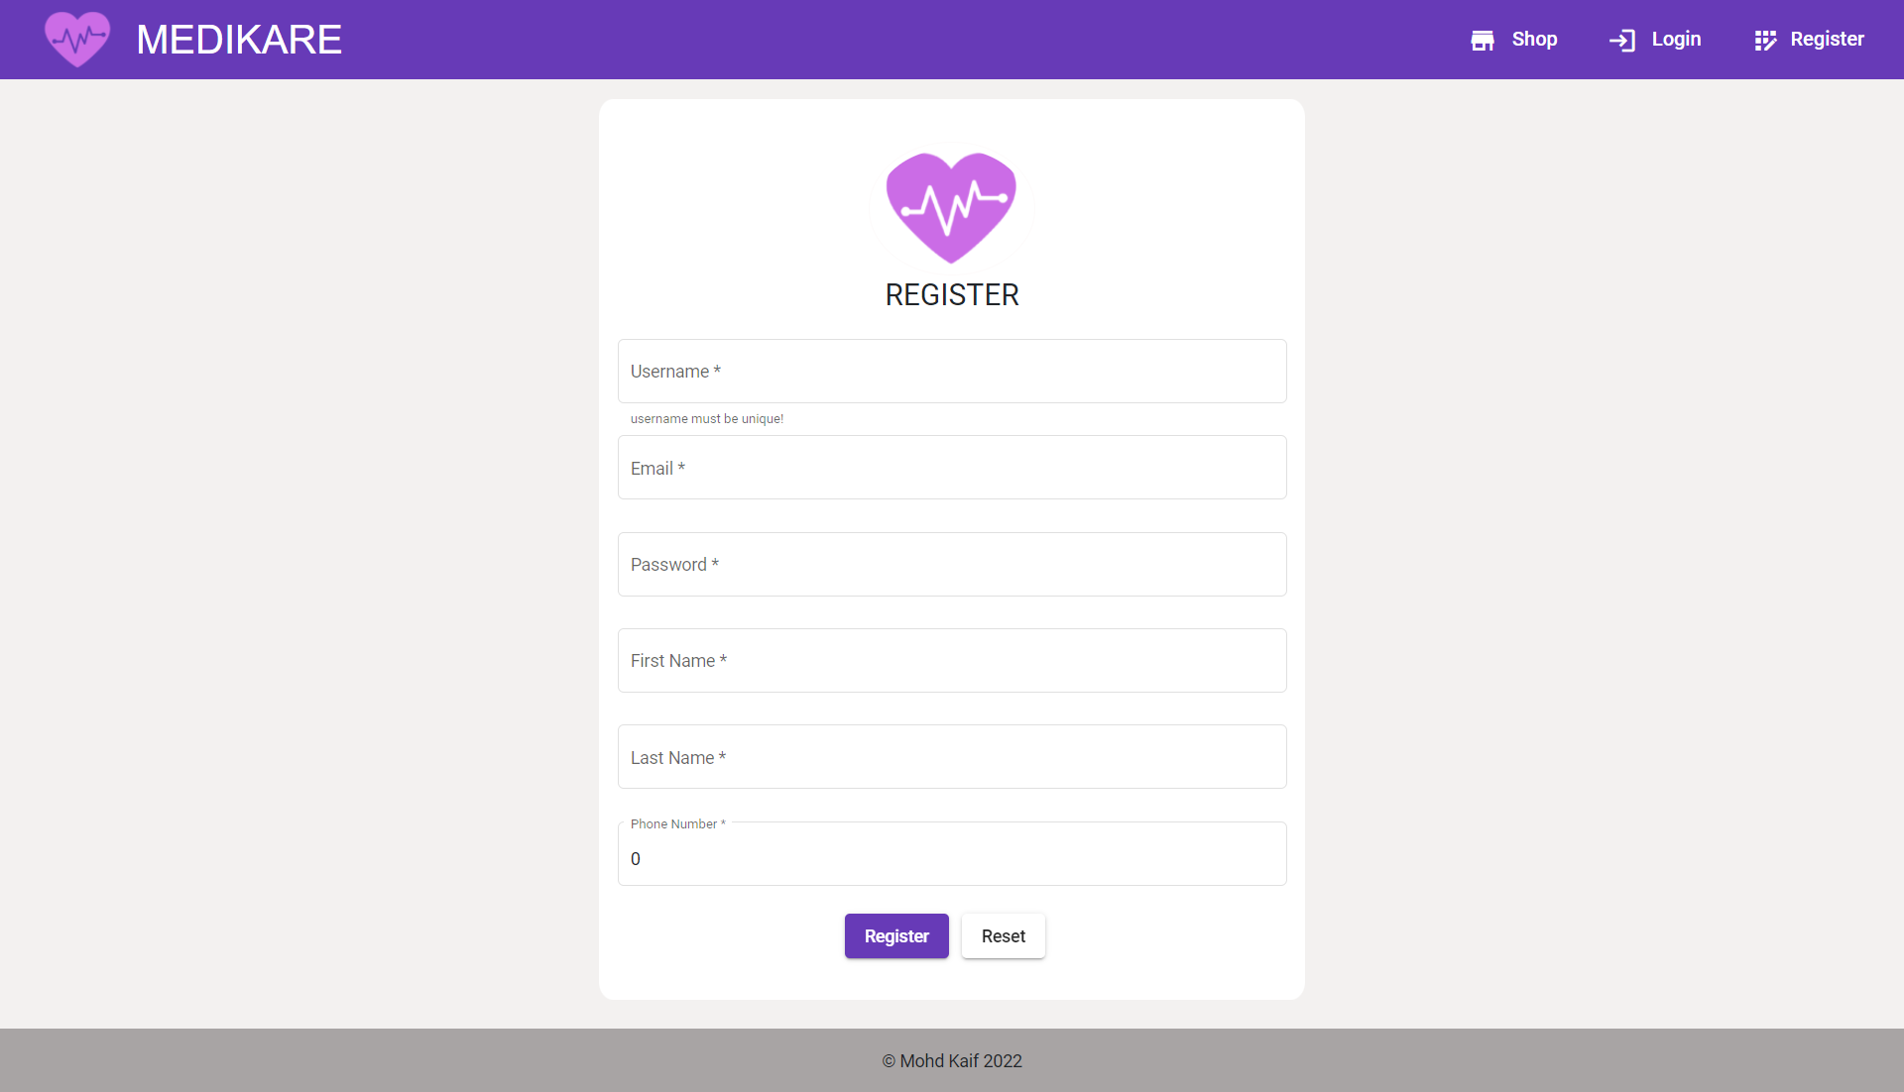register

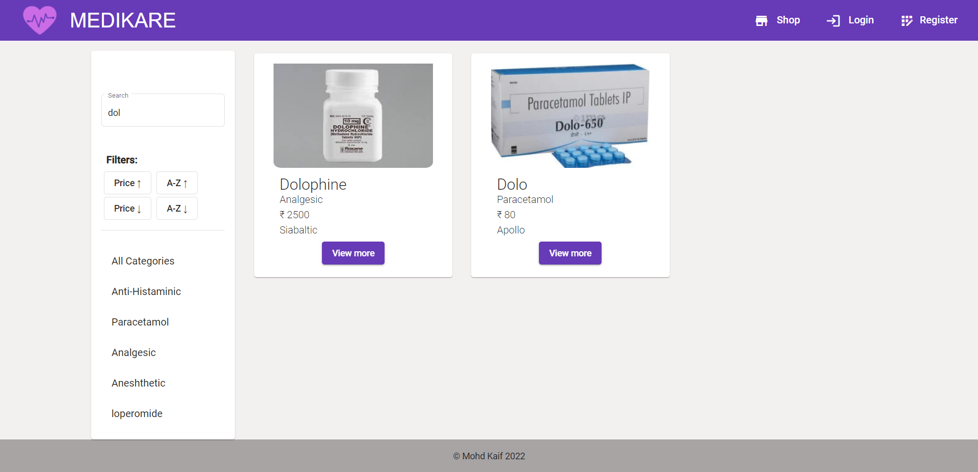searchbasedproducts

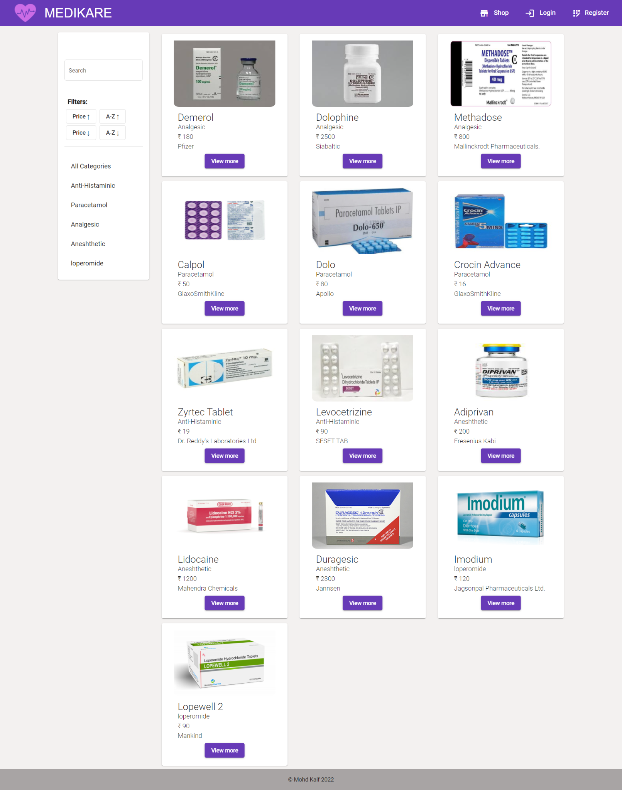shop page

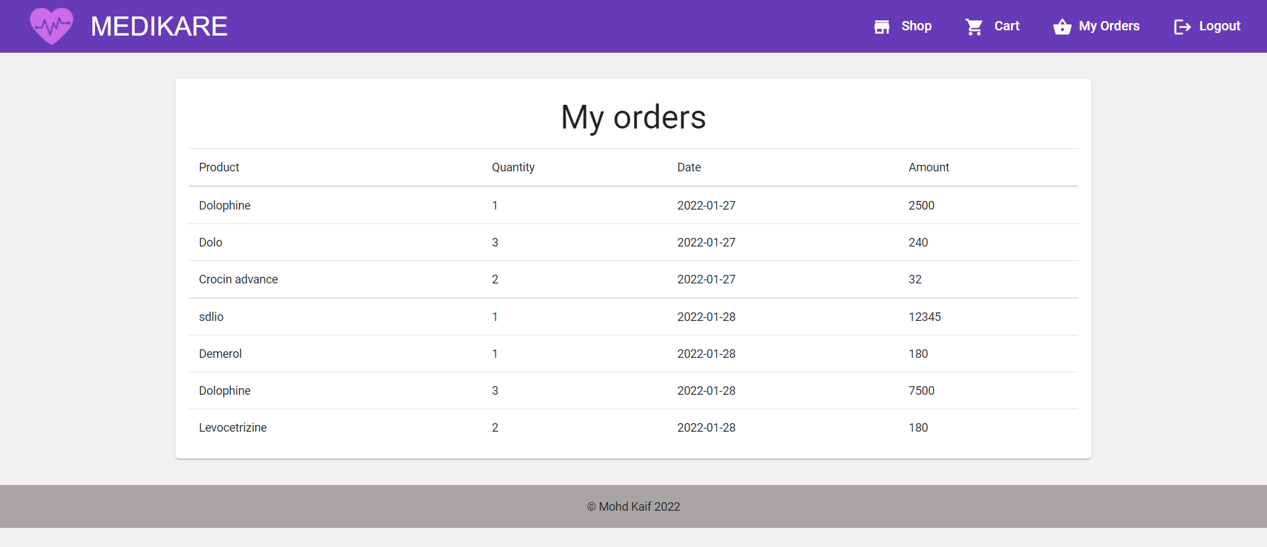user specific purchase details

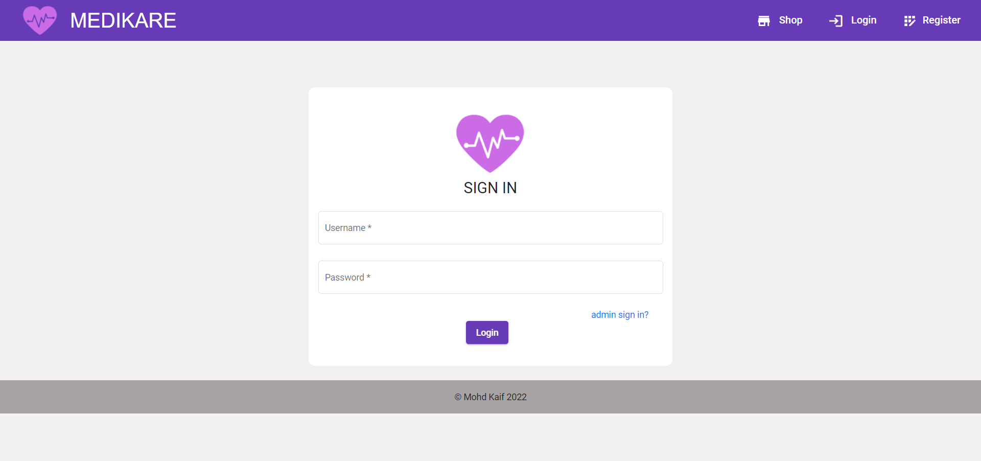user-login

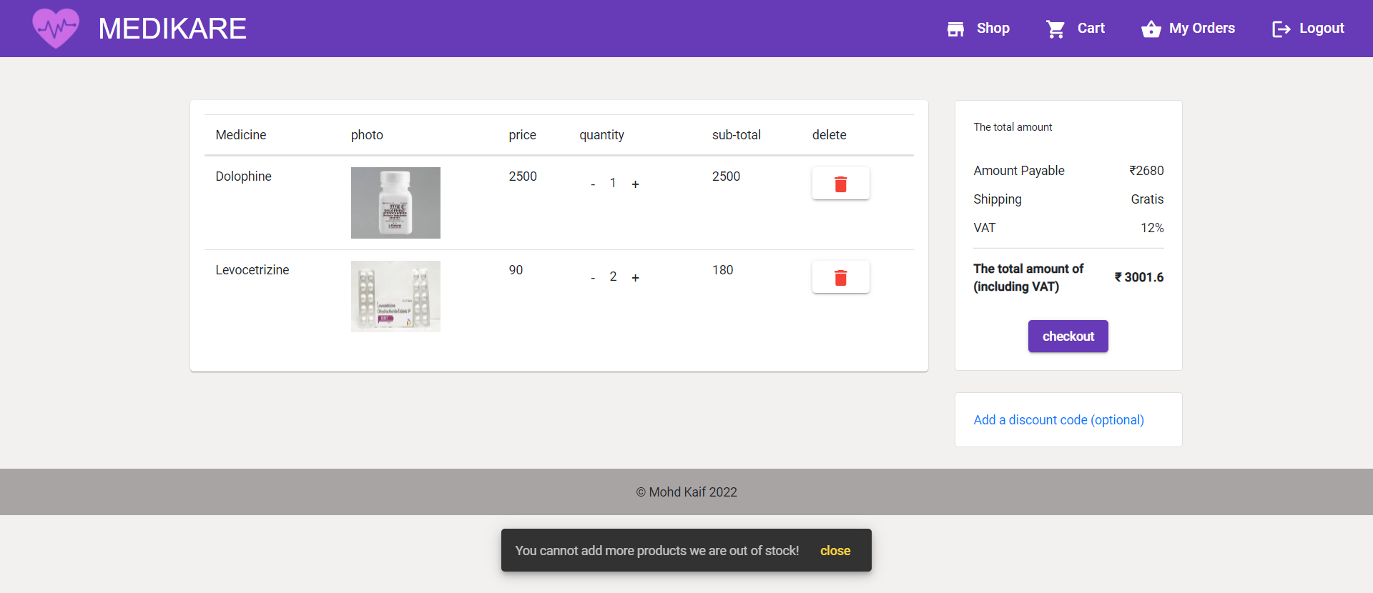validation with stock count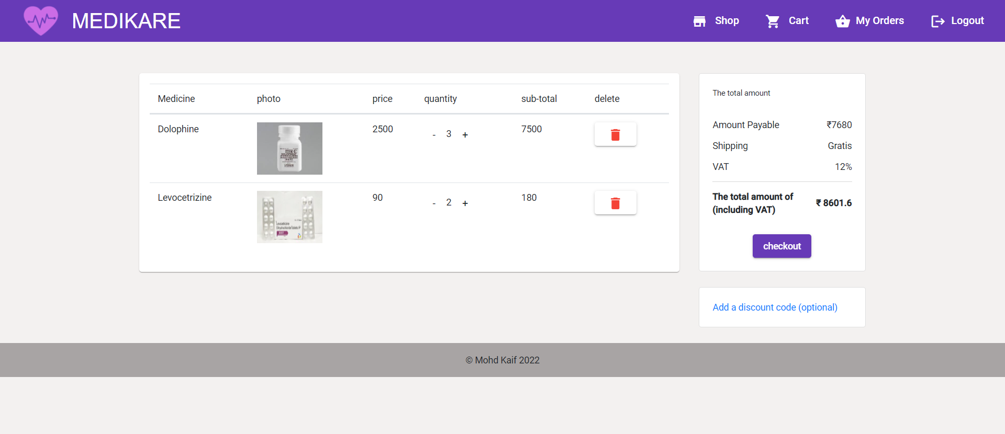variable quantity cart page